#### **Titanic Data Analysis**

**Loaded dataset using Flume**

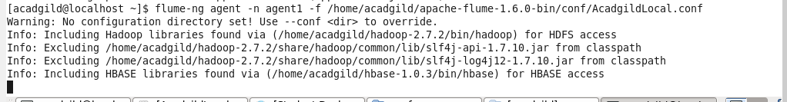

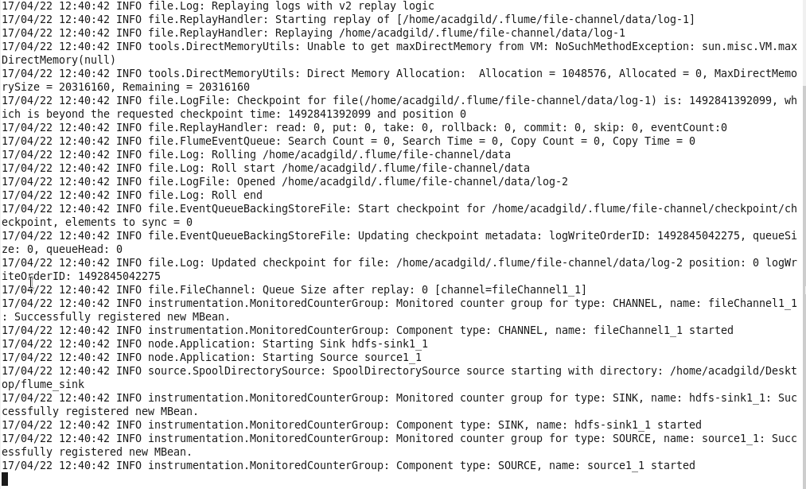

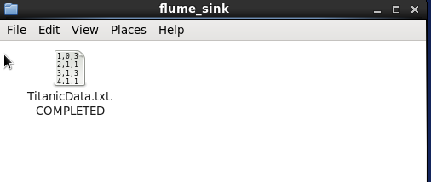

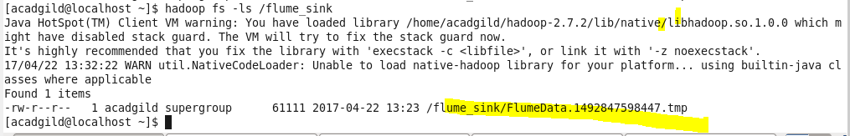

**Created Pig relation**

# 1.In this problem statement we will find the average fare of each class.

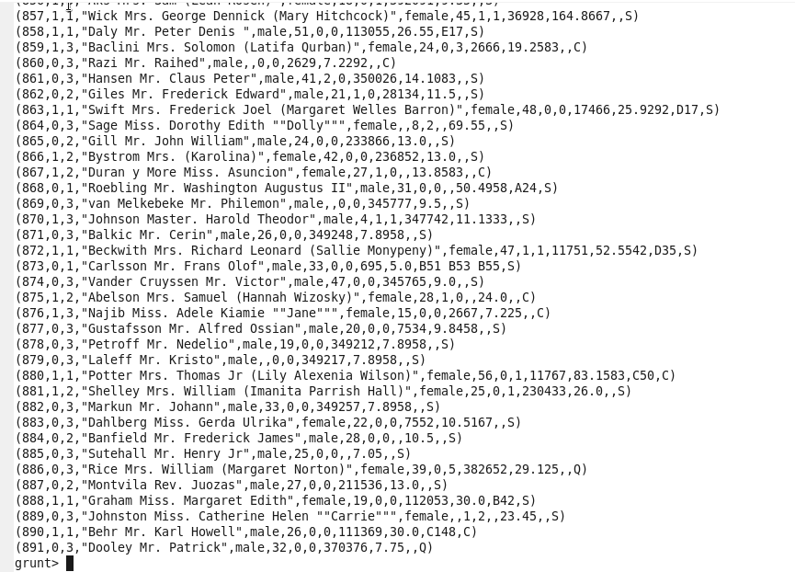



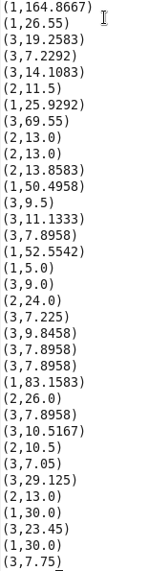

C = GROUP B BY Pclass ;

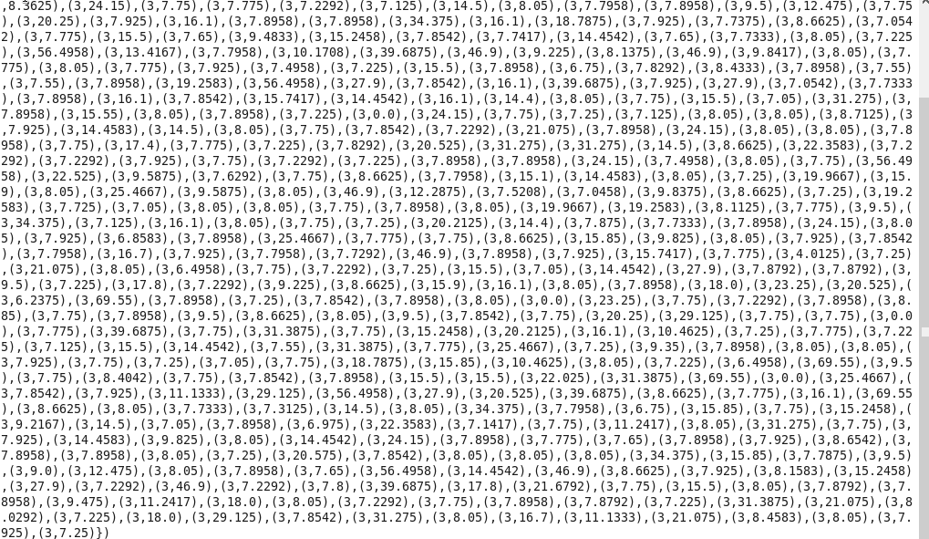



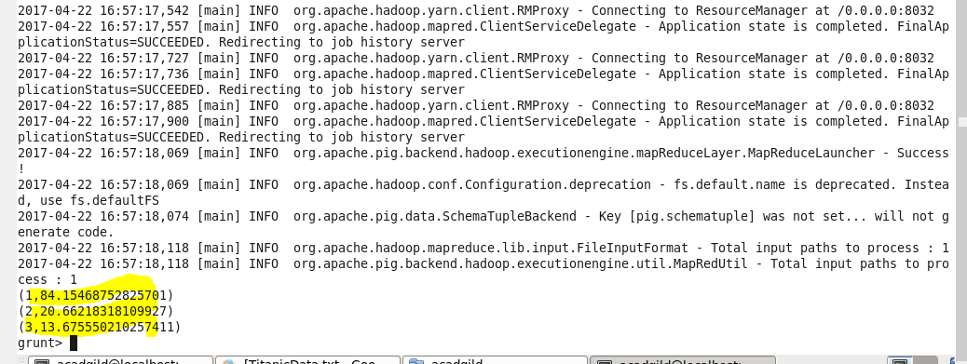

# 2.In this problem statement we will find the number of people alive in each class and are embarked in Southampton

Filtering main relation by survived , Pclass and embarked

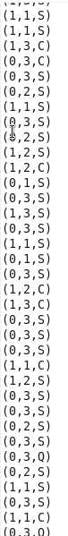



Where S stands for Southampton and survived = 0 means alive

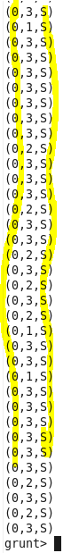

G = Group F by Pclass ;





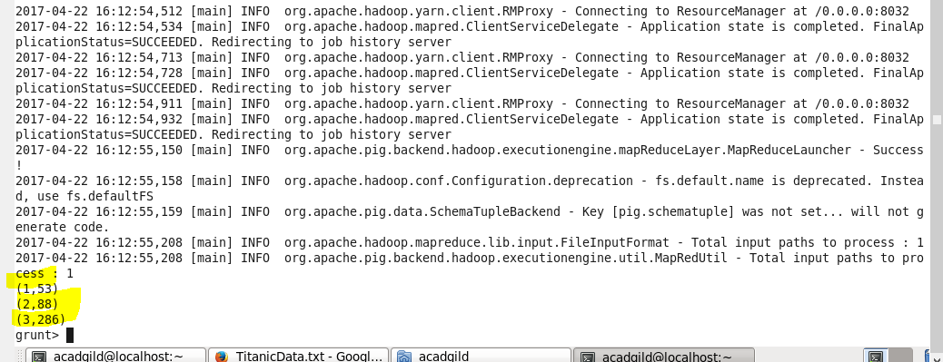

# 3.In this problem statement we will find out number of male and female people died in each class

BB = FOREACH A GENERATE Pclass,sex,survived



